***A Project report*** *on*

Association of Dietary Habits and Body Mass Index among IIIT Dharwad Students in India : A Pilot Study

*Submitted by*

Trishul K S (18BCS104)

Aditi M (18BEC002)

Jennifer Yennam (18BEC018)

K Lakshmi Gayathri (18BEC019)

*Under the guidance of*

Dr. Ramesh Athe(Assistant Professor)

Department of Data Science and Information Systems



INDIAN INSTITUTE OF INFORMATION TECHNOLOGY DHARWAD

1

It is certiﬁed that the work contained in the project report titled **“Association of Dietary Habits and Body Mass Index among IIIT Dharwad Students in India : A Pilot Study”** by “Trishul K S (18BCS104)”, “Aditi M (18BEC002)”, “Jennifer Yennam (18BEC018)” and, “K Lakshmi Gayathri (18BEC019)” has been carried out under my/our supervision and that this work has not been submitted elsewhere for a degree.

## Signature of Supervisor(s)

**Dr. Ramesh Athe** (Assistant Professor)

Department of Data Science and Information Systems

We declare that this written submission represents our ideas in our own words and where others’ ideas or words have been included, we have adequately cited and referenced the sources. We also declare that we have adhered to all principles of academic honesty and integrity and have not misrepresented or fabricated or falsiﬁed any idea/data/fact/source in our submission. We understand that any violation of the above will because for disciplinary action by the Institute and can also evoke penal action from the sources which have thus, not been properly cited or from whom proper permission has not been taken when needed.

## (Signature with date) (Signature with date)

**Trishul K S Aditi M**

18BCS104 18BEC002

Computer Science and Engineering Electronics and Communication Engineering

## (Signature with date) (Signature with date)

## Jennifer Yennam K Lakshmi Gayathri

18BEC018 18BEC019

Electronics and Communication Engineering Electronics and Communication Engineering

**Approval Sheet**

This project report entitled titled **“Association of Dietary Habits and Body Mass Index among IIIT Dharwad Students in India : A Pilot Study”** by “Trishul K S”, “Aditi M”, “Jennifer Yennam”, and “K Lakshmi Gayathri” is approved for the degree of Bachelor of Technology in ‘Computer Science and Engineering’ and ‘Electronics and Communication Engineering’.

## Supervisor (s) Dr.Ramesh Athe

Department of Data Science and Information Systems

## Date:

**Place: IIIT-Dharwad**

**Organization of the Project Report**

**OBJECTIVE**

**BACKGROUND**

**METHODOLOGY**

**STATISTICAL METHODS**

**PLAN OF WORK**

**PHASE 1**

**PHASE 2**

**PHASE 3**

**INTRODUCTION**

**MATERIALS AND METHODS**

**RESULT**

**T-TEST CODE**

**CONCLUSION**

OBJECTIVE

To correlate Body Mass Index (BMI) and Dietary Habits among IIIT DHARWAD students.

BACKGROUND

Adolescence is the age where the influence of the marketing world is high and choice of right food and exercise becomes hurdled. The World Health Organization alarm on increasing NCDs among adolescents ratifies the need for appropriate intervention at this age group. The alarming rise in overweight and obesity among young adults which forms a key link to the upsurge of other non-communicable diseases like diabetes, hypertension, stroke and myocardial infarction is a major concern. These diseases though have a complex aetiology, can be easily prevented by adopting healthy dietary and lifestyle habits. Since behaviors are formed in the early years of life, this study assesses the dietary habits of students and its association with BMI.

METHODOLOGY

This study is conducted on 100 students of IIIT Dharwad, with data collected on their age, diet, family history, weight, height, blood group and more through a questionnaire. BMI is calculated from height and weight. BMI is distributed by the criteria of the World Health Organization.

STATISTICAL METHODS

Data is compiled and analyzed for percentages and proportions. Descriptive statistics (frequency, percentage, arithmetic mean and standard deviation) are used to describe the subject characteristics.

To answer the main objective of this study, that is the relationship between dietary patterns with Body Mass Index status among the selected sample, chi-square test will be used.

PLAN OF WORK

PHASE 1

We have surveyed about the dietary habits of students of IIIT Dharwad by collecting data on their age, diet, family history, weight, height, blood group and more through a questionnaire.

PHASE 2

We analyze the collected data and calculate their BMI by the criteria provided by the World Health Organization by statistical approach for classification according to their BMI. We can take help of python programming for analysis.

PHASE 3

We try to find a pattern or a relationship between dietary habits with Body Mass Index status among the selected sample, using statistical methods such as chi-square test.

INTRODUCTION

Epidemiological transition in relocating the etiological fields of morbidity and mortality from infections to Non-communicable diseases took an alarming deviation when World Health Organization (WHO) declared obesity as a global epidemic with major implications on human health in 1997. Nutritional transition has also occurred over the last four decades with the food consumed by humans having an average 7% decrease in Carbohydrate-derived energy and 6% increase in energy derived from fats. There has been a decline in consumption of traditional diets which contain grains, vegetables and fruits and increase in unhealthy modern diets rich in fat, sugar and salt. Urbanization and Globalization have influenced the cultural values of people in selecting fancy and high calorie fast foods, popularly known as ‘Junk foods’ over their healthy counterparts. Physical inactivity has partnered unhealthy diet as the socio-economic transition made decline in traditional agricultural hard work to intermittently active computerized occupational activity which renders only 14% of the population in India involved in regular non-occupational physical activity. Adolescence is the age where the influence of marketing world is high and choice of right food and exercise becomes hurdled. The WHO alarm on increasing NCDs among adolescents ratifies the need for appropriate intervention at this age group. Hence this study was undertaken to establish the association between diet, and Body Mass Index (BMI) among the students of IIIT Dharwad.

MATERIALS AND METHODS

This descriptive cross-sectional study was carried out in April 2021. Students of IIIT DHARWAD who were 17– 22years were taken as the study population. Information was collected through Google forms. Information related to sociodemography, knowledge on nutrition and practice of healthy eating, health risk behavior, and anthropometric data were recorded in structured self-administrated questionnaire. Weight and height of the respondent and the WHO guideline was followed to calculate their body mass index (BMI) and classify them in different group. Data were analyzed and interpreted using descriptive statistics such as frequency, percentage, and mean, standard deviation. Chi-square test was applied to analyze qualitative data while P ≤ 0.05 was taken as statistically significant.

RESULT

A total of 100 respondents age ranging from 17 to 22 years were included in this study. Among them, 18.8% were girls while 81.2% were boys. Majority of the respondents were aged 20 and proportion of normal BMI was more among them (46.4%).. Normal BMI was reducing while age was increasing even though there was no significant relationship in between age and BMI. Habit of consuming cool drinks, exercising and history of family obesity was statistically significant with the p values being 0.04, 0.02 and 0.03 respectively. By T-test we find that the factors such as obesity in the family and consumption of fast food as well prove to be statistically significant.

Below you will find the calculated values in the table and code and result or t-test :

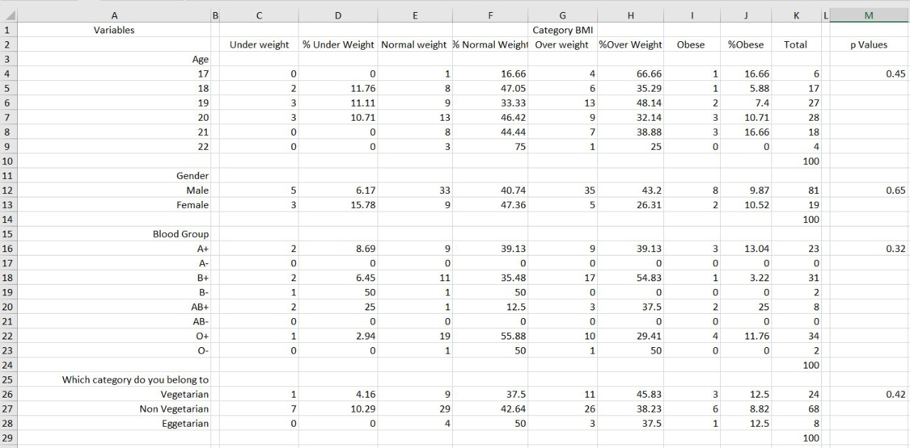

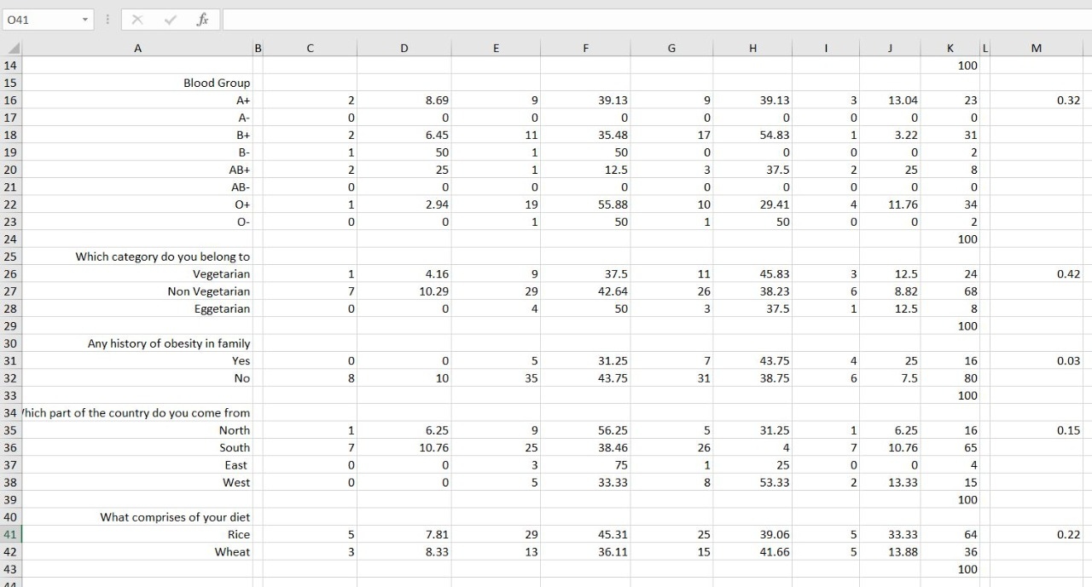

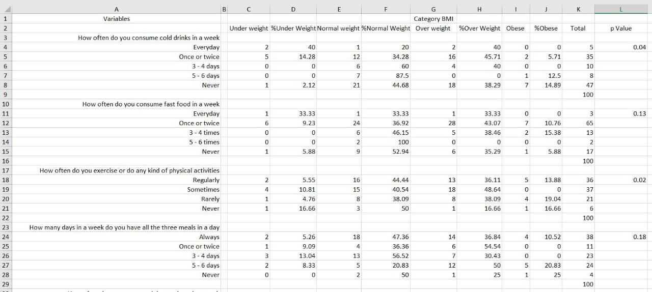

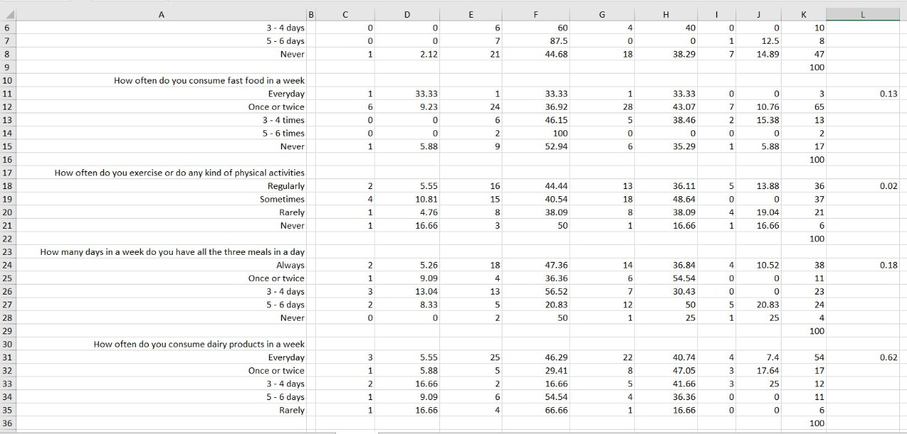

T-TEST CODE

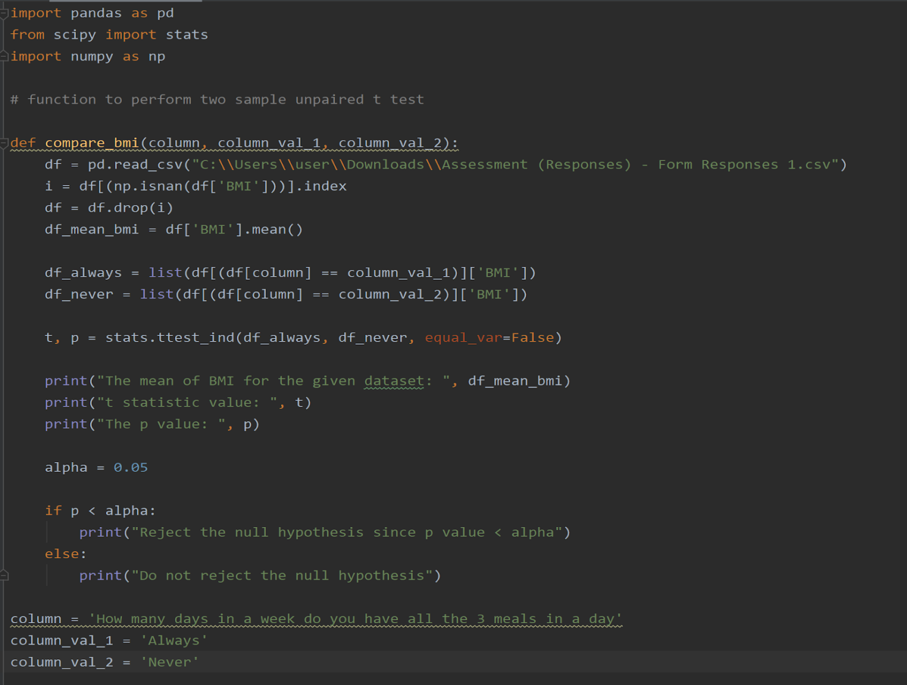

Functioning of t-test

1. Consider the column “How many days in a week do you have 3 meals a day”

* Compare to see if the mean BMI (Body Mass Index) is different for the people who always eat 3 meals a day in a week to the people who never eat 3 meals a day in a week.

The null hypothesis H0: The BMI is different for the people who always eat meals a day in a week to the people who never eat 3 meals a day in a week.

The alternative hypothesis H1: The BMI is not different for the people who always eat meals in a day in week to the people who never eat 3 meals a day in a week.

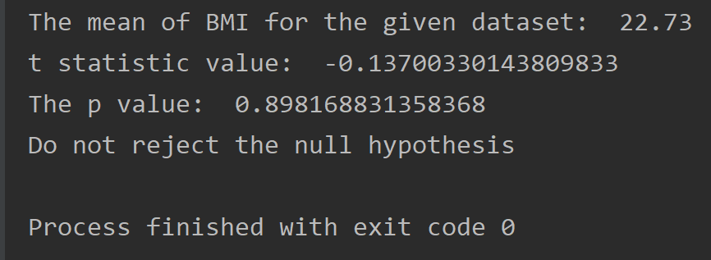

The null hypothesis was accepted for all but two cases which were

1. Do you have a family history of obesity?

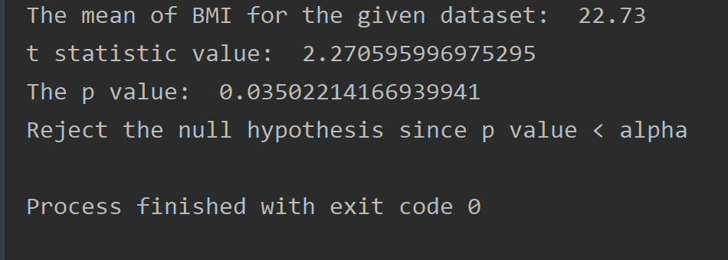

So in this case we reject the null hypothesis that says BMI is different for people with family history of BMI and proves that alternative hypothesis that says BMI is not different for people with family history of BMI making it statistically significant factor in its relation with BMI.

Similarly with the second case that is

1. How often fast food was consumed in a week?

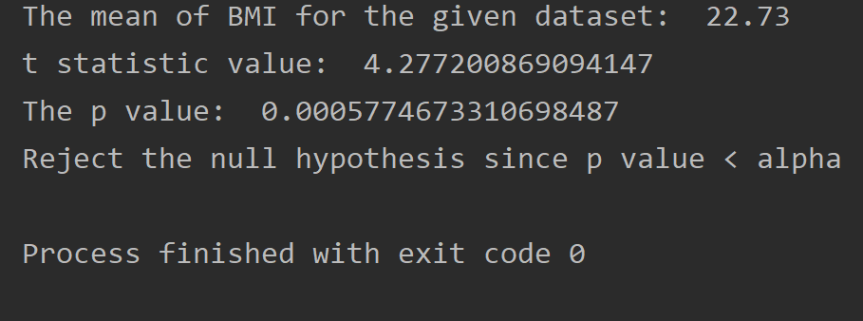

Similarly in this case we reject the null hypothesis and accept the alternative hypothesis that says fast food consumption is a statistically significant factor in its relation with BMI.

CONCLUSION

Consuming cold drinks and fast food were common among late adolescent students in urban area. Due to unhealthy eating habit, they are not able to maintain normal BMI. Together with that, they are adopting health risk habits which are problematic and need immediate attention for healthy future generation. On the positive note exercising regularly helps to maintain a healthy BMI.